RG65 CLASS RULES
2022
Version 2022.1
Introduction

The Intent of the RG65 class is to promote friendly competition in the Corinthian Spirit and innovation in the design and constructionof small radio yachts.

In order to achieve this intent the policy of the RG65 Class is to have a rule set that is sufficiently simple to be understood by novice radio sailing enthusiasts, broad enough to promote innovation and resist type forming, and supported by procedures based on trust in competitors.

The class rules for the RG65 Class are “Open”class rules where anything not specifically prohibitedor specified by the Class Rules is permitted. Individual rules may require, limit, or prohibit as necessary.

While wanting to keep the class as open as possible we should all try to work within the “spirit” of these rules and where a rule interpretation or amendment is needed you should address this through the appropriate channels.

This introduction does not form part of the Rules

Part A. ADMINISTRATION 4
Section A. GENERAL 4
A.1. LANGUAGE 4
A.2. DEFINITIONS 4
A.3. ABBREVIATIONS 5
A.4. AUTHORITIES 5
A.5. ADMINISTRATION OF THE CLASS 6
A.6. SAILING INSTRUCTIONS 6
A.7. CLASS RULES AMENDMENTS 6
A.8. CLASS RULES INTERPRETATION 6
A.9. CERTIFICATION 6
A.10. COMPLIANCE WITH CLASS RULES 7
Section B. BOAT ELIGIBILITY 8
B.1. CLASS RULES AND CERTIFICATION 8
Part B. REQUIREMENTS AND LIMITATIONS 9
Section C. CONDITIONS FOR RACING 9
C.1. COMPETITOR 9
C.2. HULL 9
C.3. HULL APPENDAGES 9
C.4. RIG 10
C.5. SAILS 10
C.6. EQUIPMENT 11
Section D. HULL 11
D.1. GENERAL 11
D.2. HULL 12
Section E. APPENDAGES 12
E.1. GENERAL 12
Section F. RIG 13
F.1. GENERAL 13
F.2. SPARS 13
Section G. SAILS 13
G.1. GENERAL 13
G.2. SAIL AREA 14
Section H. MEASUREMENT 14
H.1. MEASUREMENTS AND CALCULATIONS 14
Part C. APPENDICIES 15
H.2. SAIL IDENTIFICATION 15
H.3. SAIL MEASUREMENT 18
H.4. HULL MEASUREMENT 20
H.5. RIG MEASUREMENT 22
H.6. CERTIFICATION 24

ADMINISTRATION

GENERAL

LANGUAGE

The official language of the class is English and in case of dispute over translation the English text shall prevail.

Any drawings are shown for ease of interpretation of these Rules only. Where any drawing contradicts any text in these rules, the text shall prevail.

The word “shall” is mandatory and the word “may” is permissive.

Except where used in headings when a term is printed “underlined” the definition in these class rules applies.

DEFINITIONS
Appendage | The rudder and/or keel.
Boat | A sailing boat that shall comply with the RG65 class rules.
Certification | The process of certifying that equipment used is in compliance with the class rules, either through Self Certification or Official Certification
Class Rules | The rules of the RG65 class
Constitution | The RG65 International Class Association (ICA) Constitution
Datum Waterplane | A waterplane determined through measurement of the hull which may not be the same as the true waterplane when the boat floats in water.
Event Limitation Mark | A mark added at an event to signify that the item was declared to  the event organisers
Hull | The hull shell including any transom, the deck including any superstructure, the internal structure including any cockpit or deck hollows and the fittings associated with these parts.
Measurer | A measurer that is recognized by the ICA or/and by an NCA/NCS. A Measurer shall carry out fundamental measurement of the boat and its rigs, in accordance with these class rules
Monohull | A boat with one hull
Official Certification | A measurer may certify a boat and its rigs, enabling the relevant NCA or NCS to deliver a certificate of measurement
Regulations | The RG65 ICA Regulations
Rig | The spars, spreaders, rigging, fittings and sails
Self Certification | The methods by which a boat and its rigs are declared by its owner/operator that they conform to the class rules.
Spar | The main structural part(s) of the rig to, or from, which sails are attached and/or supported.

ABBREVIATIONS
ICA RG65 International Class Association
NCA National Class Association
NCS National Class Secretary

AUTHORITIES

The class authority is the ICA.

No legal responsibility with respect to these class rules, or accuracy of certification, rests with:
the ICA;
any NCA;
any NCS;
any measurer.

No claim arising from these class rules can be entertained.

ADMINISTRATION OF THE CLASS

The administration of these class rules shall be carried out by the ICA which may delegate the administration to an NCA or NCS.

SAILING INSTRUCTIONS

Apart from amendments permitted in A.6.2, sailing instructions may vary these class rules only with the prioragreement of the ICA.

Sailing instructions or notices of race for an event may:

specify a maximum depth allowance for boats.

CLASS RULES AMENDMENTS

Amendments to these class rules shall be proposed in accordance with the ICA Constitution and Regulations

CLASS RULES INTERPRETATION

GENERAL
Interpretation of class rules shall be made in accordance with the ICA Constitution and Regulations.

AT AN EVENT
Any interpretation of class rules required at an event may be made by the event technical committee or by a group formed of a minimum of 2 measurers so long as none of those measurers would gain any unfair advantage over the rest of the competitors. Such interpretation shall only be valid during the event and the organising authority shall, as soon as practical after the event, inform the ICA.

CERTIFICATION

Certification
Certification of a boat is by means of Self Certification or Official Certification requiring the operator of a boator a measurer to declare that all components of the boat are in accordance with the rules.

Certification Declaration
Declaration of certification shall be made using the forms made available by the ICA and shall be presented to event officials on request.

Boat Registration Number and Boat Certificate

Aftercertification an NCA or NCS may deliver a boat number;

After official certification an NCA or NCS may deliver a boat certificate.

COMPLIANCE WITH CLASS RULES

A boatceases to comply with the class rules upon:

use of equipmentthat does not comply, or causes the boat not to comply, with limitations in the class rules;

a change of class rules that causes equipment in use to cease to comply, except where the equipment complied with the class rules in force at the time of its previous certification.

A boat that has ceased to comply with the class rules may be brought into compliance by replacing equipment that does not comply with the class rules with equipment that does comply.

BOAT ELIGIBILITY
For a boat to be eligible for racing, it shall comply with the rules in this section.

CLASS RULES AND CERTIFICATION

The boat shall:

bein compliance with the class rules;

have a Certificate delivered by;

an NCA or NCS after Measurercertification;

the owner or operator after Self Certification.

have valid certification marks as required;

at a National, Continental, or International event, have a valid certificate issued by an NCA or NCS.

REQUIREMENTS AND LIMITATIONS
The competitor and the boat shall comply with the rules in Part B whenracing.

Certification control to check compliance with rules of Section C is not part of certification.

Equipment Inspectionis used to check compliance with the rules of Section C.

CONDITIONS FOR RACING

COMPETITOR

Limitations

One competitor only shall control the boat.

The competitor shall not be substituted during an event.

HULL

LIMITATIONS

The geometry of the hull shall not be changed during an event.

Thesamehull shall be used during an event except when thehullhas been lost or damaged beyond repair.

Replacement of thehull may be made only with the approval of the race committee who shall then remove or cancel any event limitation mark attached to the replaced hull.

HULL APPENDAGES

LIMITATIONS

The sameappendages shall be used during an event except when an appendage has been lost or damaged beyond repair.

Replacement of appendages may be made only with the approval of the race committee who shall then remove or cancel any event limitation mark attached to the replaced appendage.

USE
The Appendages:

containing or forming the ballast shall not be rotated relative to the hull;

shall be attached to the hull at the centreplane;

shall not project fore or aft of the hull in relation to the datum waterplane;

Shall not project outside the beam of the hull;

shall not be shifted, articulated, retracted, or extended.

RIG

LIMITATIONS

Not more than four rigsshall be used during an event.

Spars lost or damaged beyond repair may be replaced only with the approval of the race committee who shall then remove or cancel any event limitation mark attached to the replaced item.

USE
The rig shall not project fore or aft of the hullin relation to the datum waterplane.

DIMENSIONS
The dimension from the highest point of any rig to at least one point on the deck centreline shall not exceed 110 cm. Any wind indicator shallnot be part of this measurement.

SAILS

LIMITATIONS

Not more than four (4)rigs, each consisting of one or more sails, shall be used during an event.

A sail of one rig shall not be used with a sailof another rig.

A sail shall not be omitted from a rig.

Reefing is prohibited.

The race committee may attach event limitation marks to sails at an event.

When a sail has been lost or damaged beyond repair it may be replaced only with the approval of the race committee who shall then remove or cancel any event limitation mark attached to a replaced sail.

IDENTIFICATION

Theclass insignia, identification numbers and national lettersshall be shown in accordance with H2.

EQUIPMENT

EQUIPMENT

No more than two control units shall be used.

A rudder control unit shall control the rudder only.

A sheet control unit shall control the sail(s) only.

Except where achieved by mechanical systems connected to a control unit, automated control of rig and/or sails and automated steering and/or navigation are prohibited.

On board camera(s) and/or the use of images from any source while racing are prohibited.

Except for the establishment and maintenance of a radio control link, control unit positioning information, signal strength, and battery status information, radio transmissions from the boat while racing are prohibited.

HULL

GENERAL

RULES
The hull shall comply with the current class rules.

HULL

DIMENSIONS

The maximum hull length in relation to thedatum waterplane is 66.1 cm.

MATERIALS

All materials used shall be legally and commercially obtainable and usable without restriction in the territory where the boat is being operated.

At the bow, at least the first 0.4cm of the hulls length shall be made of elastomeric material.

The elastomeric material in B.2.2.2 shall be a minimum of 0.3 cm wide at one point.

CONSTRUCTION

The hullshall be a monohull.

Except for the trunking for appendages the hull shall not have:

voids in the waterplane;

voids in the profile below the waterplane;

hollows in the plan view that exceed 0.3 cm;

hollows in the profile under the waterplanethat exceed 0.3 cm;

transverse hollows in the undersurface of the hull that exceed 0.3 cm when tested parallel to the waterplane.

FITTINGS
Fittings shall not project outboard of the hull.

APPENDAGES

GENERAL

RULES
Appendages shall comply with the current class rules.

MATERIALS
All materials used shall be legally and commercially obtainable and usable without restriction in the territory where the Boat is being operated.

RIG

GENERAL

RULES
Rigs shall comply with the current class rules.

SPARS

SPAR DIMENSIONS
The maximum permitted cross section of the main structural part of a spar, and the combined cross section at junctions of spars, is 1.2 cm.

SPAR FITTINGS
Spar fittings that do not form part of the spar itself are not limited in cross section provided that they are not used to unreasonably increase sail area or similar.

SAILS

GENERAL

RULES
Sails shall comply with the current class rules.

CERTIFICATION
The following marks shall be included:

at the head an alphanumeric reference to link the Sails in the Certification documents;

at the tack the area of the sail in square centimetres and rounded to one decimal place;

permanent marks indicating the extremes and special points of the divisions used for its surface area calculation.

CERTIFICATION CONTROL AND EQUIPMENT INSPECTION

During certification and equipment inspection:

battens neednot be removed;

stays not exceeding 0.1 cm in diameter inside luff tabling need not be removed;

tell tales overlapping the sail edges shall be ignored;

discontinuous attachments on the luff shall be disregarded provided their total length measured along the luff does not exceed 15% of the luff length and the longest attachment is no more than twice the shortest.

SAIL AREA

LIMITATION
The measured sail area of each rig shall not exceed 2250 cm².

CALCULATION

The measured sail area of each rig is the sum of the areas of the sails used together in each rig.

All sail material shall be included in the calculation of the sail areaapart from any arc segment that may be excluded under clause H.3.1.3.

MEASUREMENT

MEASUREMENTS AND CALCULATIONS

Linear measurements shall be taken in centimetres and rounded to one decimal place

Calculated values in square centimetres shall be rounded to one decimal place

Maximum and minimum values of limitations in the class rules shall be taken as absolute limiting values.

APPENDICIES

SAIL IDENTIFICATION

Display

A boatshall display on her largest sail the class insignia as per B.2.

A boat shall display on her largest sail national letters if required by and in accordance with H.2.2 and H.2.4.

A boat shall display on all sails a sail number as in H.2.3 and H.2.4.

National Letters

National letters shall be carried at international events denoting the country of:

her NCA/NCS;

residence of her owner;

and may be carried at any other event

Sail Number

The sail number shall be two digits.

The sail number shall be the last two digits of the number allocated by their NCA or NCS and may be:

RG65 competitor’s personal number;

boat registration number;

RG65 owner’s Personal number;

RG65 Sail Number

Single digit numbers shall be preceded by a zero.

At an Event when there is a conflict between sail numbers, or when a sail number may be misread, the race committee may require that the sail numbers of one or more boats be changed to numeric alternatives.

Sail Numbering and Lettering Specifications

National letters and sail numbers shall be in capital letters and Arabic
numerals, clearly legible and of the same colour.The colour shall contrast with the colour of the body of sail. Arial typeface or similar are strongly recommended

Numbering Dimensions
Dimension | Minimum | Maximum
Height of sail numbers | 8 cm | 11 cm
Stroke thickness of sail numbers | 0.8 cm
Spacing of adjacent sail numbers | 1 cm | 2.5 cm

Lettering Dimensions

Dimension | Minimum | Maximum
Height of national letters | 4 cm | 5 cm
Stroke thickness of national letters | 0.4 cm
Spacing of adjacent national letters | 1 cm | 2 cm

Positioning

The class insignia, sail numbers and national letters shall be positioned:

on both side of the sail;

with those on starboard side uppermost;

approximately horizontally;

with no less than 3 cm vertical spacing between marks on the opposite sides of the sail.

The class insignia shall be positioned in the top ⅓ of the sail

Sail numbers shall be positioned in the middle ⅓ of the sail

National letters shall be positioned in the bottom ⅓ of the sail

Sail numbers shall be positioned such that there shall be space in front of the sail number for a single numerical prefix.

Sail Numbering and Lettering Adjustments

Where the size of the sail prevents compliance with the above rules, they shall be amended as follows and in the following order of precedence :

sail numbers may extend below the specified line.

vertical spacing between sail numbers and national letters and/or between national letters may be reduced to no less than 1 cm.

height of national letters may be reduced to no less than 3 cm or shall be omitted.

vertical spacing of sail numbers may be reduced to no less than 1 cm.

height of sail numbers shall be reduced to less than 7 cm, but no less than 6 cm, or shall be omitted.

Class Insignia

The Class Insignia attached to sails shall be a minimum of 4cm high

Class Insignias larger than 4cm high shall retain the aspect ratios of the example shown.

Drawings

Sail Identification Examples

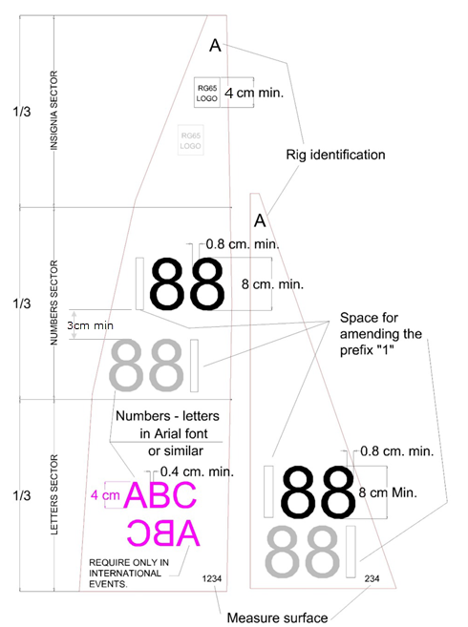

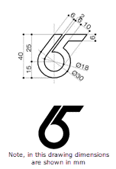

SAIL MEASUREMENT

Measurement

For the calculation of sail area, each sail shall be divided into trapezoids, triangles and/or arcs.

The trapezoids, triangles and arcs shall include all of the sail material.

If the edge of the sail forms an arc of less than 0.2 cm on an edge of a trapezoid or triangle, the segment of the resulting arc shall not be included in the surface calculation.

The radius of an arc segment shall be a constant radius.

Total area of a sail shall be the sum of all of the trapezoids, triangles and arcs.

Cross widths shall be taken:

on a double luff sail: with the supporting spar in place, to the luff, or to the fore edge of the spar, along the surface and whichever gives the greater dimension;

on a sail with the luff set in a track in the spar, to the aft edge of the spar;

on other sails, to the luff.

Calculation

The partial surfaces corresponding to divisions shall be calculated as follows:

Simple trapezoids
(B0 + B1) * h / 2

Triangles
bt * ht /2

Segments of Arc:
c * f / 1.5
Where:
B0, B1, . . ., Bn = Width of the trapezoids
h = Height of the trapezoids
bt = Base of the triangle
ht = Height of the triangle
c = Cord of the segment of arc
f = Arrow of the segment of arc

Checking the dimensions

Each sail shall have permanent marks indicating the extremes and special points of the divisions used for its surface calculation.

Dimensions are measured and from edge to edge of the sail.

The minimum tension will be applied to the sails as necessary to eliminate wrinkles along the dimension verified.

When checking declared dimensions, a tolerance of:

0.5 cm may be accepted in total measurement between clew point and head point and between the tack point and head point;

0.2 cm may be accepted in partial measurements (bases and heights).

Any permittedtolerance of measurements shall not cause the total measured sail area of a rig to exceed the sail area limitation in G.2.1.

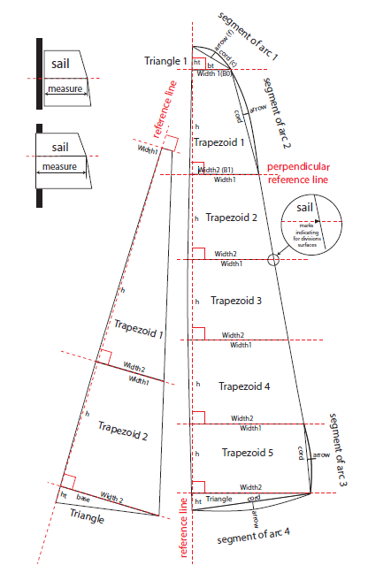

HULL MEASUREMENT

Measurement Gauge
Hulls shall be measured using a gauge that enables hull length to be measured relative to the datum waterplane of the hull.

A 3cm step inside each end of the gauge is used to establish a datum waterplane. The step may include a slot of 0.6 cm to accommodate the rudder when the hull is in the gauge.

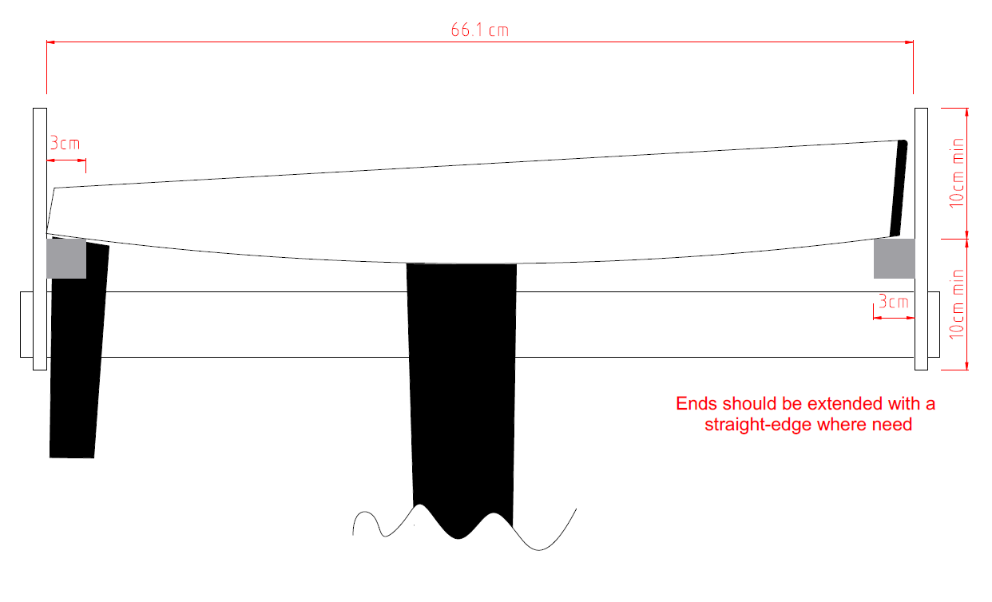

Transverse Hull Hollows
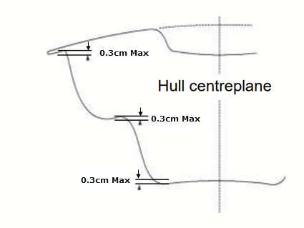

Bow Bumper
The Class Rules require that at least the forward 0.4cm of the hull shall be made of elastomeric material.
The following diagrams indicate what may or may not be acceptable bow bumper shapes.

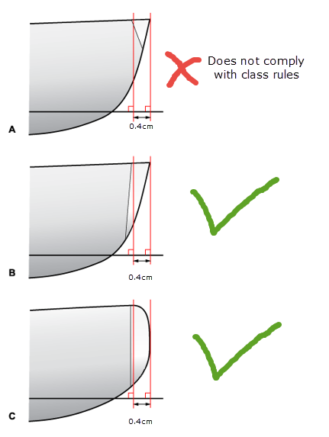

RIG MEASUREMENT

Rig Height Measurement

A cord 110cm long shall be used to ensure that the highest point of the rig does not extend more than 110cm above at least 1 point of the hull on the centreline

Examples of the Highest Points of Rig

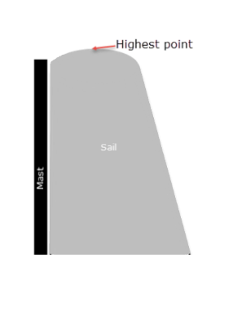
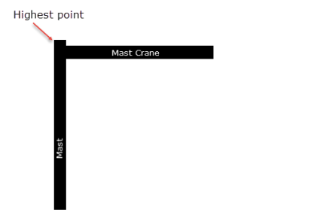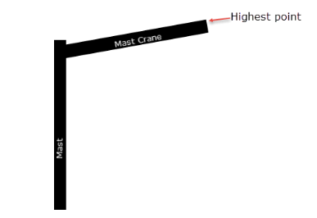

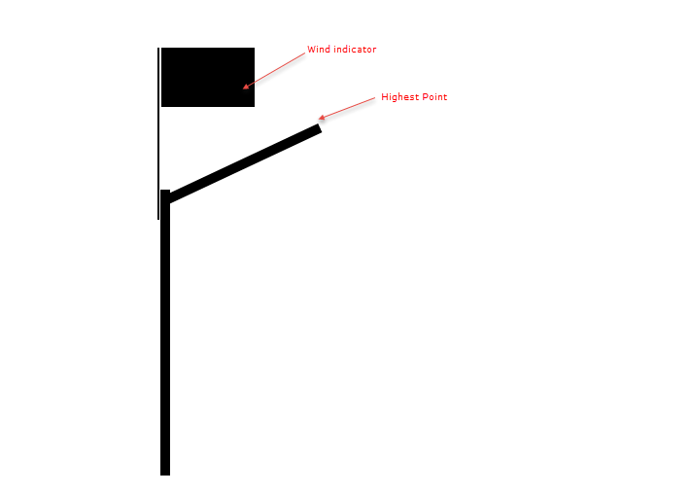

Measuring maximum height of Rig

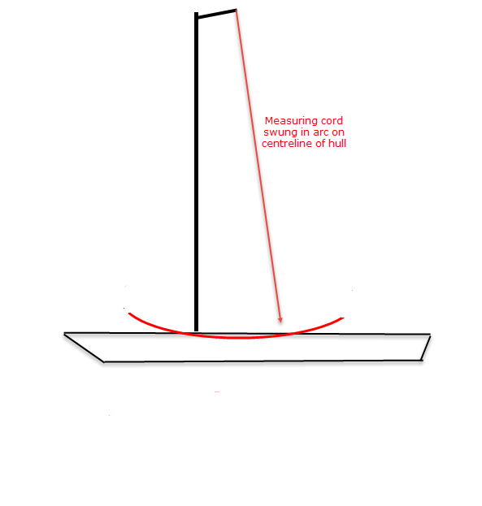

Spar Diameter

Spar Cross Sections
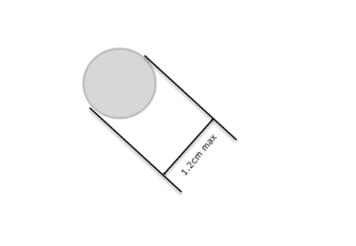
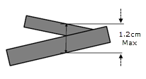

CERTIFICATION

Certification Forms

Certification forms used shall be the version of forms published on the ICA website at the time of certification.

The forms may be used for Self Certification and Official Certification. The Measurer Declaration need only be completed when the certification is made by an ICA, NCA or NCS Measurer.

Boat Certification

A boat certification form is only valid for the hull and rigs that were measured.

A hull certification form shall only certify 1 hull and a maximum of 4 rigs.

Additional rigs may be certified using additional certification forms without completing the hull certification section of the form.

PDF certification forms are available on the RG65 ICA website

